Steps to View 2024-25 Course Requests (Rising 9th ONLY) All change requests must be made before
11:59 PM on Wednesday, April 10th, 2024.

- Login to Classlink or the Parent Portal.
- Click on Infinite Campus – Student
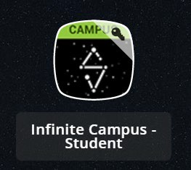
- Scroll down all the way on the left side menu and click on “Academic Plan.”
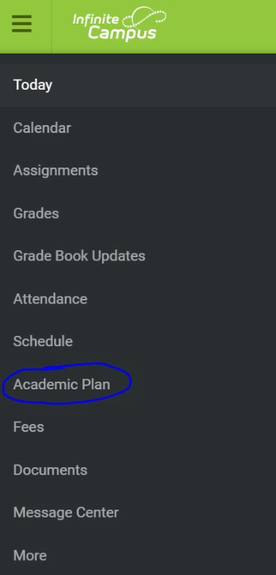
- Then click on “Next.” You can leave the “Post Grad Location” and “Post Grad Plans” blank.
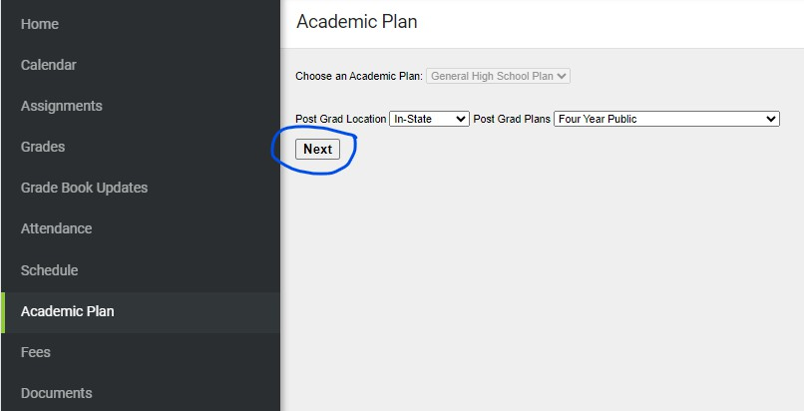

- Look in your upcoming grade level column. There, you will see your courses for “A” Semester (1st Semester) and “B” Semester (2nd Semester) for next school year (2024-25).
  - For Rising 9th graders, review your core Academic Classes: Language Arts, Math, Science and Social Studies, 4 classes (8 classes for A and B semesters together).
  - Recommendations for Academic/Core classes are based on data collected from the Middle schools.
  - Classes such as Excel or AP (Advanced Placement) are increased rigor classes. (Please note, all schools may not offer Excel and/or AP classes for each content.)
  - This is not a schedule. These are the courses that will be used to build the 24-25 SY schedule. Courses are anticipated courses and will be scheduled based on staff and course availability.
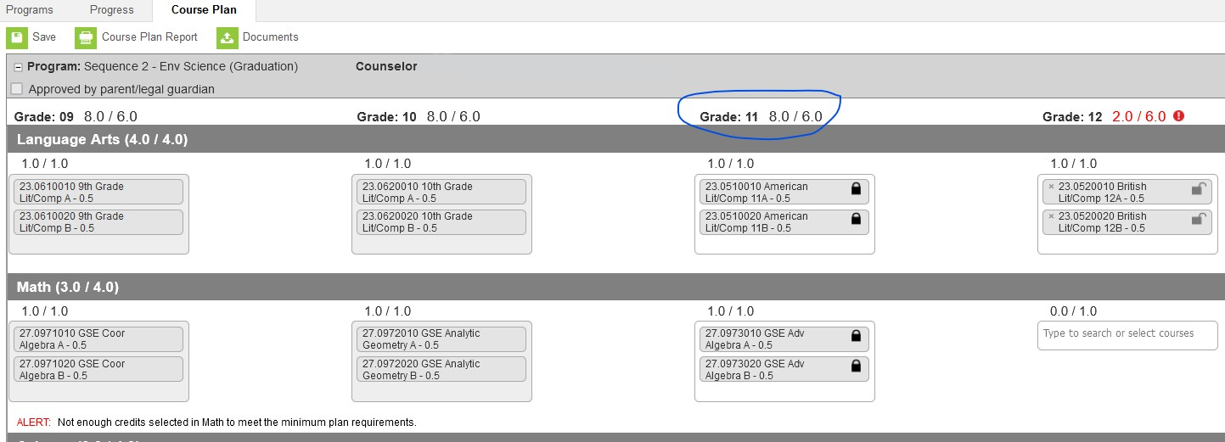
Academic Change Requests
- If making course changes for English, math, science, and social studies, please email your counselor.
- If you/your student have questions regarding an Advanced Placement (AP) course, please email your counselor.
- If your student is requesting to take a part-time course at Rockdale Virtual Campus (RVC), please email your counselor.
Heritage High School Counselor:

- 9th Grade: Scott Clark - scottclark@rockdale.k12.ga.us

Salem High School Counselors:

- Last Names A-G: Sabrina Robbins srobbins23@rockdale.k12.ga.us
- Last Names H-O: Kindra Latimore klatimore@rockdale.k12.ga.us
- Last Names P-Z: Megan Mitchell mmitchell4@rockdale.k12.ga.us

Rockdale County High School Counselor:

- 9th Grade: Jewel Jackson - jjackson3@rockdale.k12.ga.us

Full Time Rockdale Virtual Campus Students
- If you are a full-time student attending Rockdale Virtual Campus, please email your school counselor.
Rockdale Virtual Campus Counselor:
- 9th Grade: Shonnon Buggs sbuggs@rockdale.k12.ga.us

Elective Change Requests
- Elective changes are subject to course availability; therefore, if space does not permit, we will not be able to make the change; however, we will do our best.
- If your student selects a course for which he/she has already received credit or has not completed the prerequisite course(s), he/she will remain in the current selection.

Heritage High School Rising 9th Elective Change Request

Salem High School Rising 9th Elective Change Request

Rockdale County High Rising 9th School Elective Change Request

Rockdale Virtual Campus Rising 9th Elective Change Request

All change requests must be made before 11:59 PM on Wednesday, April 10th, 2024.

There will be no change requests accepted after April 10th, 2024.

